- Create a hard link for file f8

- ln f8 link8 [ To create a hard link named link8 for file f8 ]
- cat f8 [ To view the original content of f8 ]
- vi f8 [ To open f8 in vi editor and add a new line ]
- cat f8 [ To verify the updated content of f8 ]
- cat link8 [ To verify link8 reflects the same change, since a hard link shares the same inode as the original file ]

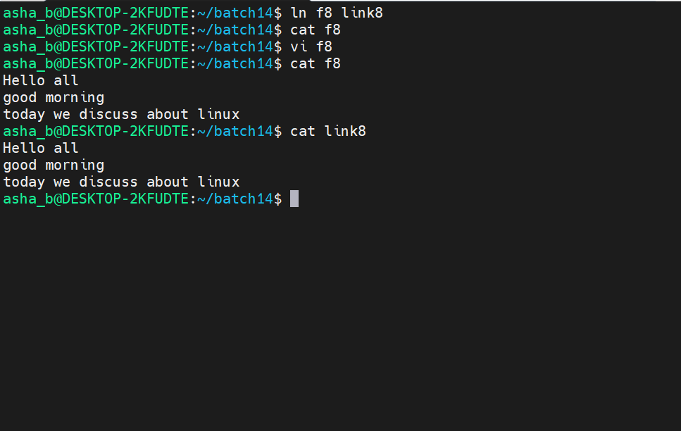

- mv f8 f9 [ To rename f8 to f9 ]
- vi f9 [ To open f9 in vi editor and add another line ]
- cat f9 [ To verify the updated content of f9 ]
- cat link8 [ To verify link8 still reflects the change even after the original file is renamed ]
- rm f9 [ To delete file f9 ]
- cat f9 [ To confirm f9 no longer exists ]
- cat link8 [ To verify link8 still works even after the original file is deleted, since a hard link shares the same data ]
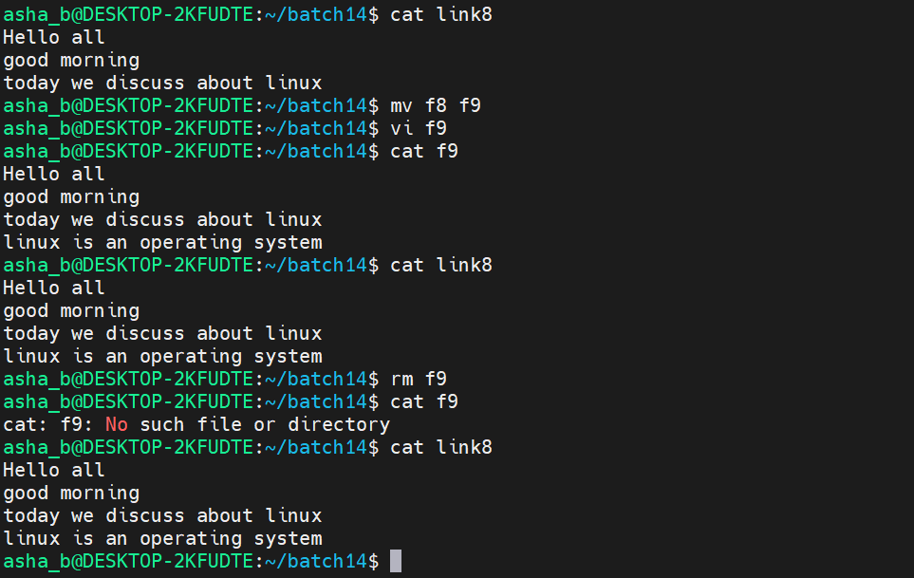

- Create a soft link for file1

- ln -s file1 link1 [ To create a soft (symbolic) link named link1 pointing to file1 ]
- cat file1 [ To view the content of file1 ]
- cat link1 [ To view the content of file1 through the soft link link1 ]
- vi file1 [ To open file1 in vi editor ]
- cat file1 [ To verify the content of file1 ]
- cat link1 [ To verify link1 still reflects the content of file1 while the file name is unchanged ]
- mv file1 file2 [ To rename file1 to file2 ]
- cat file2 [ To verify the content is preserved under the new name file2 ]
- cat link1 [ To show that link1 breaks once the original file is renamed, since a soft link points to a path and not an inode ]
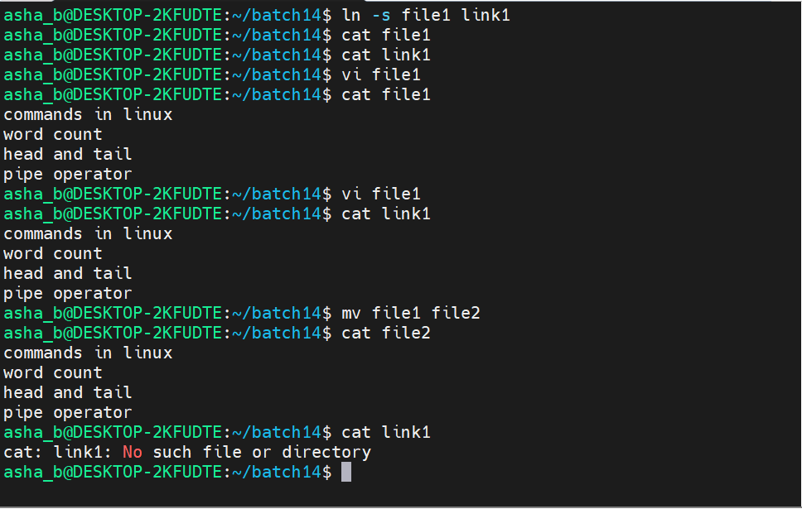

- rm file2 [ To delete file2 ]
- cat file2 [ To confirm file2 no longer exists ]
- cat link1 [ To confirm link1 remains broken since the target file no longer exists ]

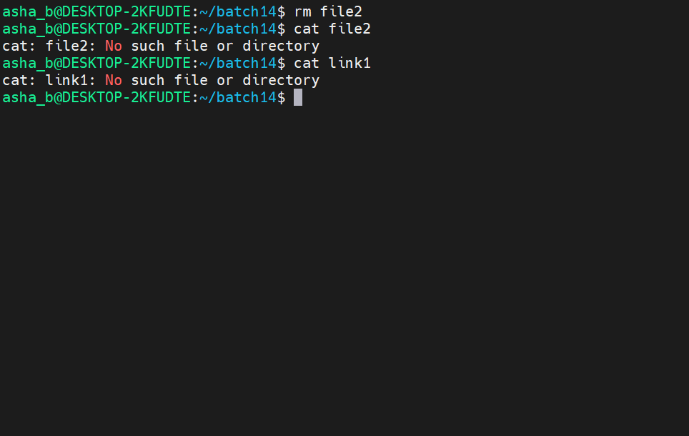
- ls -l [ To display a detailed listing of files, directories and links along with their permissions, owner and size ]
- tree [ To display the directory structure in a tree format ]

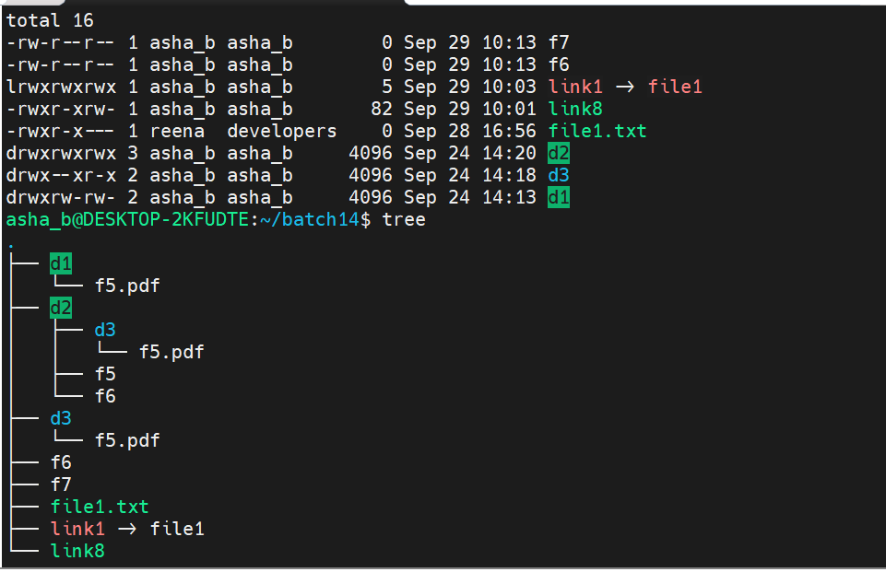

- View the content of file f7 using more command
- more f7 [ To display the content of file f7 page by page on the terminal ]

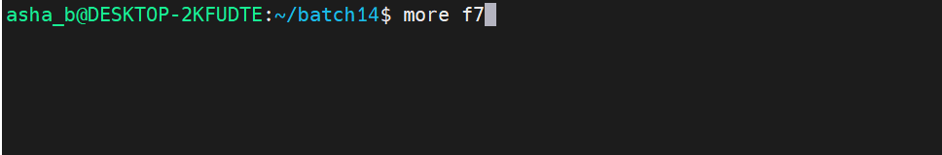
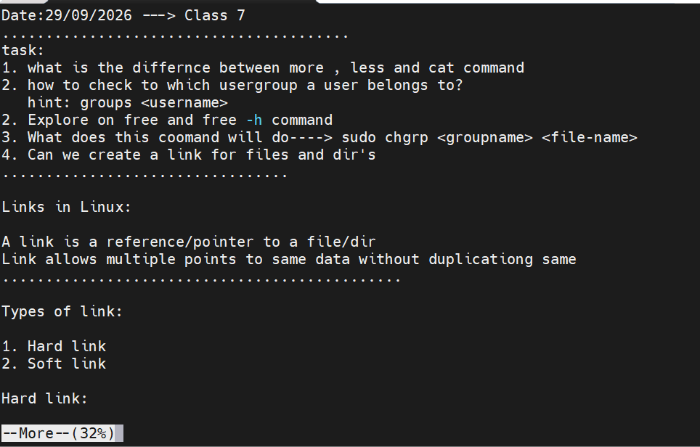

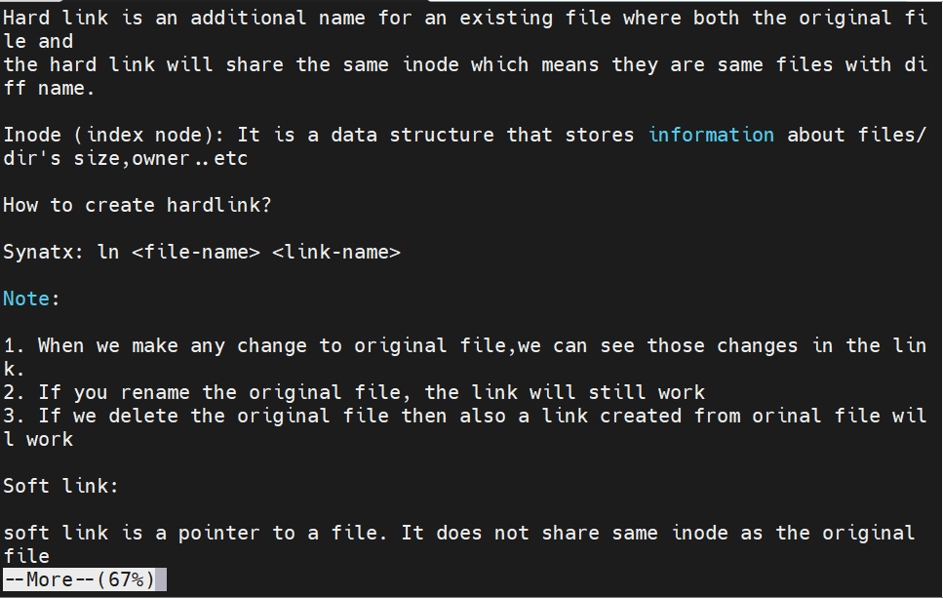
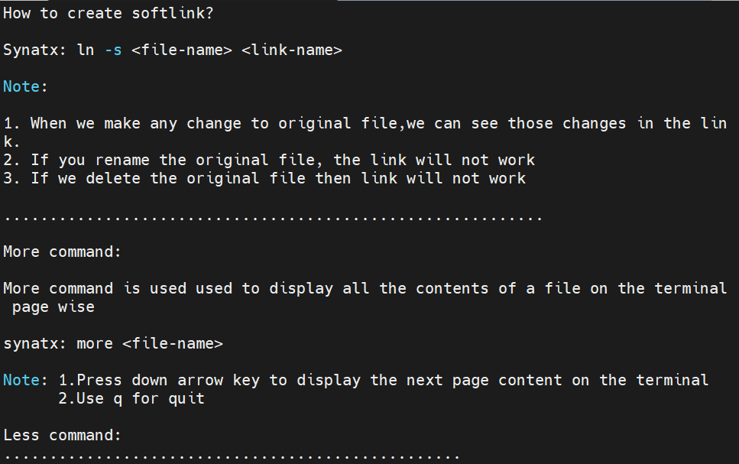

- View the content of file f2 using less command
- less f2 [ To display the content of file f2 page by page, allowing both forward and backward navigation ]

